|  |  |
| --- | --- |
| Date | 15 November 2024 |
| Team ID | 739973 |
| Project Name | Fertilizer Recommendation System for Agriculture Using AI |
| Maximum Marks | 3 Marks |

**Define Problem Statements (Customer Problem Statement Template):**

The Fertilizer Recommendation System for Agriculture Using AI is a data-driven solution that aims to optimize crop productivity by providing personalized fertilizer recommendations to farmers. By analyzing soil properties, crop types, weather conditions, and historical yield data, this system employs AI algorithms to suggest the most suitable fertilizer types, quantities, and application methods for each field. The goal is to enhance nutrient management practices, improve crop yields, and promote sustainable agriculture.

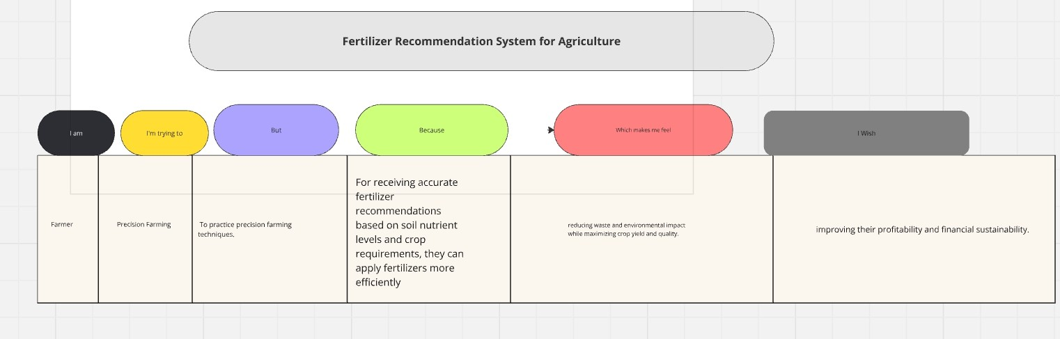

|  |  |  |  |  |  |
| --- | --- | --- | --- | --- | --- |
| **Problem**  **Statement (PS)** | **I am (Farmer)** | **I’m trying to** | **But** | **Because** | **Which makes me feel** |
| PS-1 | **Precision Farming**  Soil Health Monitoring | practice precision farming techniques. | No proper analyzing soil properties, crop types, weather conditions. | They can apply fertilizers more efficiently, reducing waste . | maximizing crop yield and qualitymaximizin g crop yield and quality. |
| PS-2 | gathers data on soil nutrient levels and crop performance. | They enables to monitor soil health trends. | farmers can make informed decisions regarding soil fertility management. | crop rotation strategies, and long-term soil health preservation. |

|  |  |  |  |  |  |
| --- | --- | --- | --- | --- | --- |
|  |  |  |  |  |  |
|  |  |  |  |  |